|  |
| --- |
| **Memo on Black Lives Matter** |
| by Jess Esplin Ph.D. Student in Political Science, UW-Madison |
| Final Project for Fall Semester 2020, due 12/15/2020  Completed for PS 904 AP Seminar at UW-Madison  Instructors: Dr. Kathy Cramer & Dr. Deb Roy |
|  |

INTRODUCTION

This memo is addressed to local supporters of the Black Lives Matter movement in Utah with the intent to advise advocates on how Utahns are thinking about the movement and suggest effective ways to address the issue and shape the local public discourse. I use a hybrid format in the form of an issue brief combined with the additional information required in academic papers to convey my findings and recommendations to supporters of this movement, as well as supplementary context from class content and data.

First, I must acknowledge my own positionality as a white woman and my support for the core goal of the Black Lives Matter movement to value the lives of Black people at equal measure to that of white people in the United States and combat the racial injustice that leads to disproportionate rates of Black lives lost at the hands of police across the country. I do not abbreviate the name of the movement and refer to it in its entirety as Black Lives Matter to respect the numerous Black people that have been killed and whose names and memories are the driving force of the movement.

While my personal values shape the questions I address and the applications I hope my work can take, I believe my analysis on this issue stands up to criticism across the ideological spectrum – in evaluating how public thought is shaped and expressed, characterizing and contextualizing these expressions, and interpreting their implications for further action. Moreover, explicitly stating my personal values and positionality allow readers to better evaluate my interpretation and analysis of the facts presented, which would be more difficult without this transparency.

Drawing on political science literature that push the boundaries of public opinion, I use the term public thought instead, and broadly define this as what ordinary people think and feel about their political environment, as expressed through conversations, discussions, statements, and reactions to the thoughts and opinions of others, and include the process by which these expressions are formed and develop over time in this definition. These expressions of public thought can be found in talk radio engagement, tv interviews, social media posts and private messages, public statements and essays, private in-person conversations, etc., providing a variety of modes of expression from which data can be collected.

Building on the foundation that Kinder (1998) outlines in understanding public opinion as “a product of a complex and multilayered social experience” (p. 817), I take the lessons learned in the works of Cramer (2016), Iyengar et al. (2012), and Weaver et al. (2019) to operationalize public thought under this broad definition and attempt to capture how a person’s lived experience and perspective forms a specific lens with which they view the world around them, constructing individual opinions and attitudes, as well as group attitudes and a larger aggregation of public opinion as a whole. Whereas Cramer (2016) investigates these expressions of public thought in-depth through many conversations, I can only evaluate the available expressions in a limited sense given the available data and post hoc methods as outlined in the next section. Nevertheless, this definition of public thought guides my analysis and interpretation of the data.

Furthermore, I draw on the seminal text of Nelson and Kinder (1996) as theoretical motivation for the selection of my data sources. Their work on issue framing suggests specific frameworks for political issues develop in people’s minds through interactions with other people, including the political elite, which then constrains opinion within that frame. I apply this concept to my study of public thought on Black Lives Matter in Utah by evaluating how local news and media sources (in this case, radio programs) frame the movement and explore how the public receives and engages with these frameworks through interactions on social media.

Although much of the class discussion and radio data made available to the class centered around talk radio programs, with traditional programming formats in which members of the public call in to share their opinions on current events, typically preceded and followed by discussion between the radio show hosts, this type of radio programming is not consistently available across the country and is becoming less prevalent as new media technologies and formats have developed. Moreover, talk radio programs typically have specific audiences that may not be representative of the country or even the cities or regions in which they are based. Most current talk radio show audiences skew older and more rural, meaning analysis of public thought expressed via talk radio may not be generalizable to other age groups, races, or various other demographics.

One particular media format that has exploded in the last decade with the development and prevalence of smart phones is podcasts, which can vary in format from topic-centered discussion and/or interviews to programs spanning multiple topics and current events to game-show type formats. It is now not unusual for radio programming to double as both live or pre-recorded shows that are aired on the radio and also released as recorded podcasts available to audiences at their leisure. With the rise of podcasts, some radio shows have adapted the traditional call-in radio show format to this new medium – some podcasts ask listeners to leave voicemails for show hosts that are later played in the episode for the entire audience to hear, or they may solicit listener engagement via email and other forms of communication[1]. Although podcasts may not necessarily be replacing talk radio with exactly the same type of content and engagement, it must be acknowledged that they have become a highly popular type of audio programming, due in part to their convenience and widespread accessibility.

Social media use and online social interactions have also rapidly increased in recent decades. Some of the most popular social media platforms include Facebook, Twitter, Instagram, YouTube, TikTok, and Pinterest (Robinson, 2020). This behavioral trend has only increased in 2020, as the COVID-19 global pandemic has forced many to severely restrict their in-person social interactions for much of the year, leading to even higher rates of online activity and social interaction[2].

Consequently, researchers must adapt to these changing social behaviors and communication modes. Evaluating public engagement on social media platforms with radio shows and podcasts that do not follow a traditional talk radio format may still offer valuable opportunities to “listen in” to expressions of public thought and provide helpful context on how public opinion on various issues is being shaped, especially where traditional talk radio programs are not available or their audiences are not representative. The contributions of podcasts towards understanding public thought is best understood as supplementary to talk radio programs, as well all other modes of expression and formation of public thought, such as facilitated conversations, social media posts, formal essays, surveys, etc. Studying all available forms of these expressions are critical to developing a comprehensive view of public thought in its entirety.

There may be a division in U.S. public opinion on the Black Lives Matter movement contingent on the organization centered in that rhetoric. While some center the larger Black Lives Matter Global Network organization, others center local community action organizations. The global/national organization is only one of several well-known large-scale organizations that has helped the movement reach a national audience, whereas the protests and continued activation of Americans across the country have been largely organized by small, dispersed local community action groups relying on participation from their own communities, even in Coeur d’Alene, Idaho (Carlton, 2020). One prominent example of this contrast is when President Trump described the goals of “the BLM organization” as antithetical to his supporters’ goals at one of his campaign rallies, using the national organization as a framework to describe and criticize the movement as a whole (Villarreal, 2020). The contrasting focus on organizations of different scope is puzzling to some degree – why does it matter which organization you refer to when discussing the Black Lives Matter movement?

Previous work in public opinion may provide some guidance toward a theoretical framework to understand this divergence in organizational emphasis. Schattschneider’s foundational text on the “contagiousness of conflict” described the scope of conflict as expanding or contracting as the number of people involved and engaged in the conflict changed (1960). The organizational emphasis within political rhetoric on the Black Lives Matter movement may serve to frame the dialogue within parameters of different scope that may shape, or be influenced by, public opinion on the movement overall. Schattschneider’s conception of conflict suggests the rhetoric centering the Black Lives Matter Global Network is an attempt to expand the scope of the conflict whereas rhetoric centering local community organizing groups may be an attempt to limit the scope of conflict. Alternatively, Zaller’s transformative RAS model conceptualizes public opinion formation as an individual sampling from a collection of considerations, comprised of a combination of preconceived beliefs and new information (1992). Using this model, political rhetoric addressing the Black Lives Matter movement with reference to organizations of different scope may simply reflect different ways to sample information about the movement when forming a consideration or opinion on the issue. If this is the case, we might expect these differences in information to merely be the result of differences in partisan elite framing on the issue.

Without traditional talk radio shows in Salt Lake City and Provo, I turn to radio shows (some of which double as podcasts) produced in these locations by prominent local news stations, including KUER public radio, KSL Newsradio, and BYU Radio. I identify local radio shows that engage with the Black Lives Matter movement and evaluate their content as well as their social media presence. I also explore public engagement with respect to the Black Lives Matter movement, primarily through social media interaction. To further characterize discourse on the movement in these locations, I analyze relevant reporting and news articles produced by local news organizations as well as public engagement with their posts and articles on social media. Finally, I evaluate the Black Lives Matter-related Twitter data provided to the class for references to movement organizations.

I restrict my public thought data to only those expressed between March 1st and July 15, 2020, as instructed for the final project, but note that there appears to be relevant content and engagement with the Black Lives Matter movement from the selected radio programs and news sources after this period.

BACKGROUND & LOCAL CONTEXT

Protests and public outcry surged across the country in response to the death of George Floyd in Minneapolis, Minnesota on May 25, 2020. Floyd, a Black man, was killed by a white police officer in Minneapolis, Minnesota on May 25th while being arrested (*The New York Times*, 2020). Floyd’s death followed shortly after the deaths of Breonna Taylor in Kentucky and Ahmaud Arbery in Georgia and sparked protests worldwide, generating unprecedented support for the Black Lives Matter movement (Brown, 2020). There were mass protests in every state and estimates of more than 15 million participants in the United States (Buchanan, Bui, & Patel, 2020). The protests dominated the news and other forms of media for weeks.

Local news coverage in Utah shows the progression of events in Salt Lake City and throughout the state as public outcry grew in response to George Floyd’s death, from small demonstrations immediately following his death to large protests in the capital city with over 2,000 in attendance shortly thereafter (Harkins, 2020, May 29; Stevens, 2020). Protests spread across the state, with demonstrators showing up even in the less populous cities and towns of Kanab, Moab, and St. George in the southern region, as well as Ogden and Logan in the northern region (Podmore, 2020; Donaldson et al., 2020).

Salt Lake City, the state’s capital city and most populous, is much more liberal-leaning overall than much of the rest of the state, though it is still home to people of diverse ideological and political beliefs. Consequently, much of local news and media sources based out of Salt Lake City are liberal-leaning. Provo, on the other hand, is heavily conservative and serves as the home to LDS[3] church-owned Brigham Young University (BYU). Despite both cities being urban in nature, they represent vastly different political ecosystems. One notable consideration is that the distinction between Salt Lake City and its surrounding towns and cities is difficult to cleanly define in some ways as a result of the area’s geography. While the city itself is confined to a relatively small area in the heart of the Salt Lake Valley, Utahns densely reside in a continuous path from the city of Bountiful all the way to the southernmost end of Provo along Interstate-15, though most of these residential areas are typically characterized as suburbs rather than typically dense city dwellings. Consequently it can be difficult to parse out the ideological divides between cities along this region. In general, however, the city of Salt Lake and its surrounding areas is considered much more politically liberal than Provo and its surrounding areas.

DATA & METHODS

To understand public thought on the Black Lives Matter movement in Salt Lake City and Provo, Utah for the given period, I examine several modes of local discussion and expression between March 1st and July 15, 2020, including prominent radio programs and local news articles, as well as social media engagement with the public for both, and supplemented by an analysis of tweets related to the Black Lives Matter movement:

* Radio programs and social media engagement
  + RadioWest (KUER in SLC; liberal-leaning)
  + The JayMac Show (KSL Newsradio in SLC; conservative-leaning)
  + The Lisa Show (BYU Radio in Provo; conservative-leaning)
  + Top of Mind with Julie Rose (BYU Radio in Provo; liberal-leaning)
* Local news articles and social media engagement
  + KUER 90.1 (SLC; liberal-leaning)
    - Article: (Terrell, R., 2020)
  + The Salt Lake Tribune (SLC; liberal-leaning)
    - Article: (Harkins, P., 2020, May 30)
  + KSL News (SLC; conservative-leaning)
    - Article: (Reiss, J., 2020)
  + Deseret News (SLC; conservative-leaning)
    - Article: (Leonard et al., 2020)
  + Daily Herald (Provo; conservative-leaning)
    - Article: (Pugmire, G., 2020)
* Black Lives Matter-related tweets collected by the MIT Media Lab

DATA

To identify the radio programs for analysis, I considered the most popular local radio stations that have talk radio programs. KUER 90.1 and KSL Newsradio in Salt Lake City are very popular, with the latter providing more examples of talk radio than the former, and providing two different ideological perspectives. In Provo, the only radio station I could identify was BYU Radio, from which I selected two popular programs that discuss news and current events: The Lisa Show and Top of Mind with Julie Rose.

From KUER 90.1, I selected RadioWest, a popular long-form radio program that has recently turned into a dual radio program and podcast. The JayMac Show was formerly a talk radio program at KSL Newsradio that appears to have ended around May 2020 when its host, Jay McFarland, began a campaign in the Republican primary race for Utah’s Congressional District 4, which includes Provo and some parts of Salt Lake City. He later loss this primary race in June to other candidates who profess support for much more extremist conservative views (Richards, 2020). McFarland had built up quite a following of listeners of the 20 years his show aired on KSL. He continued recording short episodes of his show that were available on Spotify, and which he posted on his public Facebook page, as well as Twitter and Instagram accounts for the show. I primarily used his Facebook account to evaluate social media engagement with the public, since there was less engagement with the show’s accounts on other platforms.

I listened to episodes of these programs following George Floyd’s death, selecting them based on their titles for relevance to the Black Lives Matter movement, and transcribed the most relevant quotes from them. I also identified all the social media accounts associated with the other three radio programs and reviewed their content and interactions with the public across different platforms.

For local news programs, I identified the most popular news organizations in Salt Lake City and Provo, though I could only identify one in Provo. These news organizations varied across the ideological spectrum as well. I selected specific news articles shared by these news organizations on their Facebook pages and reviewed the articles and posts for content, as well as the comments and reactions from the public.

Finally, I used the tweets provided by MIT Media Lab to complete a preliminary analysis of the most frequent words. I had intended to analyze tweets from Twitter users who had self-reported Utah as their location, but I was unable to do this as a result of my limited skills working with large data sets. Instead, I took the first 1,000 tweets to evaluate, which I realize provides little help towards analysis. Next steps include more work with this data set.

I filtered out any Twitter bots and other accounts that I could identify that do not represent real people. I constructed a word cloud of the most frequent words in these tweets, filtering out the terms Black Lives Matter and other references to the name of the movement, as shown below:

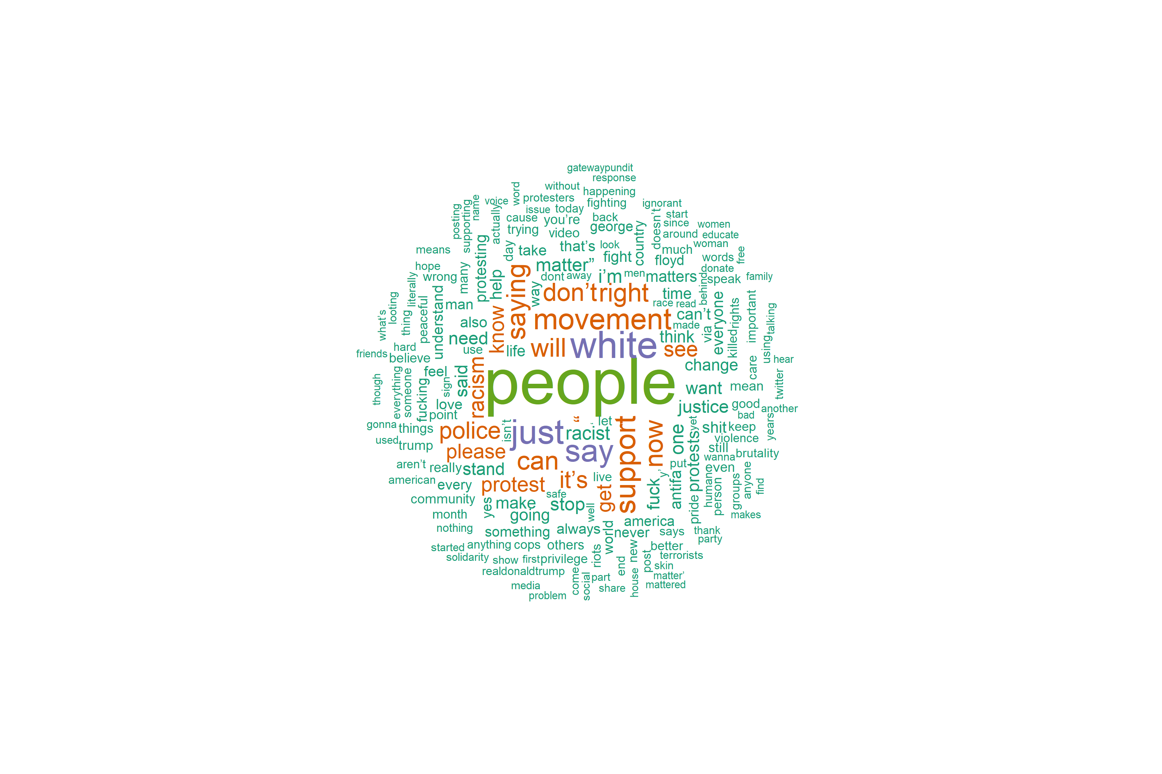

ANALYTICAL STRATEGY

I rely primarily on the qualitative method of inductive listening to identify how radio show hosts and news articles characterize the Black Lives Matter movement, by listening to the radio programs and reading the news articles and their respective social media posts. I also read through social media comments from members of the public on these posts and consider how listeners and readers respond to the way these shows and journalists portray the movement and protests and push back against those framings.

LIMITATIONS

The data I analyze are limited in scope and may not characterize the full extent of public thought in Salt Lake City and Provo, despite my best efforts to find data that spans partisan divides and other microcosms of thought in these areas. One way in which they are limited is that I was only able to use a limited number of episodes from each radio show due to time constraints, as each episode required a significant time commitment to transcribe and analyze. The same is true for my analysis of the news reporting. My time constraints also meant I was only able to conduct a limited investigation of the public engagement with these radio shows and news articles on social media platforms, since this research was also extremely time-intensive.

Furthermore, this analysis investigates the portrayal of the Black Lives Matter movement through the lens of elite framing produced by local radio programs and local news organizations and the engagement they elicit from members of the public. Other analyses might take a different approach by evaluating more expressions of thought and opinion from members of the public, solicited through surveys and interviews, or unsolicited by examining these expressions as they already exist (perhaps on social media, or in other avenues of expression). Additional approaches may look at tv news framing or print media, and engagement with the public through these mediums. The fullest picture of public thought on this issue is likely to be found through aggregating analyses from multiple approaches.

My analysis of the Twitter data is also limited as a result of my limited data analysis skills and the large number of tweets in the data set. Consequently, I am only able to perform a rough preliminary analysis on them to present a blurry picture on the expressions of public thought they contain. Further analysis might constitute a well-planned coding scheme to evaluate support and opposition to the Black Lives Matter movement, as well as a coding scheme to analyze the organizations referenced in the tweets, which would allow a more developed investigation of the research question.

MAIN FINDINGS

1. Radio programs in Salt Lake City and Provo largely support the Black Lives Matter movement, though some qualify that support by casting negative light on purported “violence” in some protests. Although social media engagement is limited overall, their listeners largely express support as well. A caveat to this is The JayMac Show, which toes the line and attempts to find a middle ground with his conservative audience.

Following broadly defined ideological divides, the four radio programs discuss the Black Lives Matter movement positively, relative to local news portrayal. While The Lisa Show and The JayMac Show express support for more conservative ideology, they largely do not appear to blame the movement for purported violence displayed in protests. The Lisa Show, for example, avoids addressing the movement for the most part and focuses on helping listeners deal with the anxiety and uncertainty resulting from widespread social unrest and the ongoing global pandemic. However, when co-host Richie Steadman does address the movement directly, he frames the death of George Floyd as murder:

“This first one, it’s the first of three memorials for George Floyd, the man who was murdered in Minneapolis. It took place yesterday.” (The Lisa Show, 2020, June 5)

The JayMac Show does not directly address the Black Lives Matter movement, for the most part.

Top of Mind with Julie Rose and RadioWest, falling under a more liberal ideological standpoint, both express clear, unqualified support for the Black Lives Matter movement. In the former’s portrayal, Julie Rose does not describe George Floyd’s death as a murder, but she does convey that it was the result of racial injustice:

“Ahmaud Arbery and George Floyd. Both unarmed black men killed by white men. Both incidents came under scrutiny only after cellphone video was made public. Ahmaud Arbery was jogging in a Georgia neighborhood when he was shot dead by a retired law enforcement officer and his son, who have now been charged with murder. George Floyd died in Minneapolis police custody this week. Bystander video of the arrest shows Floyd on the ground, struggling to breathe as a white police officer kneels on Floyd’s neck for several minutes. The officers involved in that incident have been fired and the FBI is investigating. Video is a powerful tool to prompt scrutiny, spark outrage and, hopefully, bring change. Baylor University theologian and film scholar Greg Garrett has spent the last several years using film of a different sort to prompt scrutiny, outrage and, hopefully – change – in the way white Americans think about race.” (Top of Mind with Julie Rose, Rose, J. 2020, May 28)

In a RadioWest episode that aired about two weeks after George Floyd’s death, the show solicited personal stories from three Black employees at KUER 90.1, one of which conveyed surprise that white people in Salt Lake City, Utah would show up in support of the movement and describing his feelings about the reaction:

“Friday after work, you know, I found myself streaming the images coming out of Atlanta and watching the protests happening there. That’s where I’m from, that’s where I’ve spent the past few years of my life. And I remember having a unique thought Friday night – there’s no way – this will never get to Salt Lake City. [overlaid with audio from a Black Lives Matter protest in SLC]. I didn’t expect to see the turnout that I saw. I didn’t expect to see the wide arrange[sic] of races that I saw. And to see the wide range of people, I mean more than 1,000 protestors be willing to do this, to do this on foot, to interrupt traffic, that was really shocking to see – one, as a new person in this state, but two as a journalist covering this state… So you really saw the community come together and kind of that mantle being shared that for African Americans who are protesting police brutality and racial injustice, you aren’t in this fight alone. [overlaid with audio from a Black Lives Matter protest in SLC]. You know, I still leave my house everyday as a Black man in America. And I was angry as well. I was upset. It’s like keep do what you’re doing, I get it. When I see violent events, when I see people being shot and killed by neighborhood vigilantes such as the Ahmaud Arbery case, that takes a piece of you. That could’ve been my story. I lived in Georgia. I ran on these roads so many times in communities that look nothing like me.” (RadioWest, Terrell, R., 2020, June 5)

The episode goes on to address how listeners, particularly white listeners, can learn to address racial injustice, using an interview with author Ibram X. Kendi to interpret current events and provide suggestions for listeners on how to do this.

These radio programs’ social media posts generated little public engagement across platforms, though the amount did vary somewhat by radio show, and all of them had more engagement on Facebook than any other social media platform. The Lisa Show and Top of Mind with Julie Rose had almost no engagement on their Facebook posts, whereas posts from RadioWest and The JayMac Show had a significantly higher number of reactions, comments, and shares. Despite the limited public engagement, the listeners who did engage with these Facebook posts largely expressed views in support of the radio programs’ portrayals of the Black Lives Matter movement.

One caveat to this finding, however, is that although the JayMac Show did not directly address the Black Lives Matter movement in a show/podcast episode, Jay McFarland did make a Facebook post following the May 30th protest condemning the violence that he perceived:

“People who choose violence are not protesters, they are anarchists and they need to be held accountable. To those who are protesting peacefully I say thank you. I pray for Utah tonight that cooler heads will prevail and no one will get seriously injured.” (McFarland, J. via Facebook, 2020, May 30)

Importantly, he draws a line between protestors and anarchists (or what others appear to term rioters), who “choose violence.” His listeners and others on Facebook who engaged with his post, on the other hand, largely do not agree with this distinction. One comment to this post reads:

“There’s a huge difference between protest and riot, one is usually peaceful and one is criminal. If you choose to be criminal then ya get what ya get. Nothing says I love my fellow man like a good looting and a riot. 😐 not to mention your city... 😔” (McFarland, J. via Facebook, 2020, May 30)

While McFarland also receives comments suggesting his interpretation of the protests as violent and wrong are incorrect, a majority of comments from the public seem to argue a more extreme interpretation to the right of his statement.

2. Local news on the Black Lives Matter movement largely portray local events negatively following May 30th protest, despite relatively positive portrayal of the Black Lives Matter movement overall. Social media engagement with these reports are much higher than radio programs and much more extreme in negative reaction.

Again, portrayal of Black Lives Matter protests largely followed ideological divides among news organizations, with more liberal-leaning news outlets taking a more positive perspective on the protests overall, whereas more conservative-leaning outlets more frequently used the term “riot” to describe them. However, all of the local news organizations seemed to struggle with how to portray the events of the May 30th protest in Salt Lake City, with even the more liberal-leaning outlets describing it as violent, such as the one below from The Salt Lake Tribune:

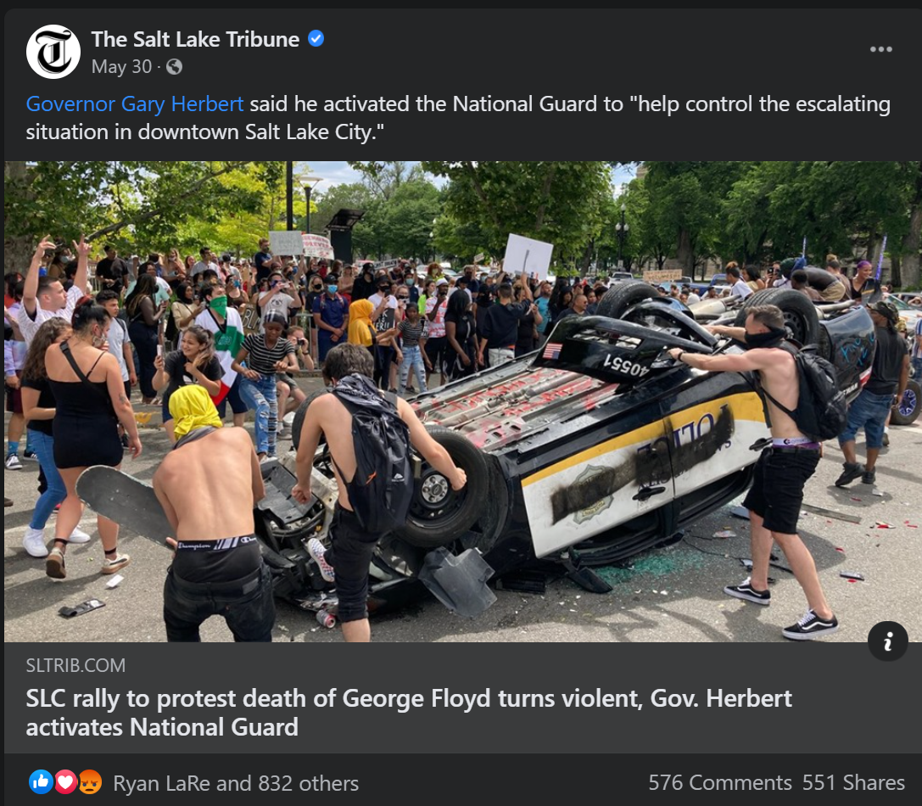

(*The Salt Lake Tribune* via Facebook, 2020, May 30)

Interestingly, an article from KSL News that appears to have been published prior to the escalation of the May 30th protest used the headline, “Demonstrators peacefully protest for 'Justice for George Floyd' in downtown Salt Lake City,” which then sparked extremely negative comments from the public:

“Your protest made no sense, and it's completely irrelevant to the area. Not only is justice already being served to the officers actually involved, but SLC PD already proved they won't tolerate an officer abusing his power when they fired Payne. There was no (logical) reason to "protest"; stand in unity, yes, of course. But regardless, at least props to those who didn't start acting like tantrum-throwing babies and stayed peaceful.” (*KSL News* via Facebook, 2020, May 29)

“SLC cannot give Floyd justice. I want justice for the riots in SLC. Justice for the damage caused by these riots. Justice for SLC!!!” (*KSL News* via Facebook, 2020, May 29)

These comments suggest George Floyd’s death does not warrant a response from residents in Salt Lake City because racial injustice is not applicable there and that the “violence” enacted in Salt Lake City is on equal level with the violence enacted against Floyd.

Overall, these framings of local events were more negative than other portrayals of the Black Lives Matter movement overall, suggesting that when events directly related to the movement took place in the communities in which these radio shows are based, hosts and show producers were more likely to have mixed reactions and difficulty weighing the different perspectives. Social media interactions with the public suggest many members of the public viewed local events more negatively than before, although the ideological divides in different outlets’ audiences could be seen prior to the May 30th protest as well. To sum up, context matters. Local radio programs and reporters were more reactive to events in their own communities, and so were members of the public who commented on their posts on social media.

Public comments on a Deseret News post and article regarding the May 30th protest sparked similar outrage, though with decidedly more partisan and extremist language. For example, one commenter suggested protestors were being paid:

“These people are out here burning up cars and burning down businesses are all funded by George Soros Hillary Clinton Barack Obama oh, the liberal Democratic Party and the Socialist. They were all expecting to have a wide support from the African American Community as well as other other ethnic groups and they're finding out they're not getting it it's turned on them and it will turn on the people that are funding this as well. These people that are out there doing this damage they think they are starting a new Revolution, in fact they don't have the brains enough to start a lawn mower. These people that are burning these cars and the tag of the police, would fall into a good category being Prime candidates of abortion at Birth. They serve no God accept Satan and we know who serve Satan and that's the liberal party. All I can say is God Bless America.” (*Deseret News* via Facebook, 2020, May 30)

Another commenter imbued their comments with religious overtones:

“Same old story through out history. Terrorist love Terror! They cloak it with a cause so they can carry out their terror. Rioters and looters love rioting and looting. And if they can attach a cause to it? Then they feel justified in their rioting and looting. Which is what they wanted to do the whole time. True Joy and Peace only comes from following and serving the Savior Jesus Christ! Help the poor and needy. Feed and cloth the hungry. As you serve and help others. True change happens to us all. Jesus Christ is the answer!” (*Deseret News* via Facebook, 2020, May 30)

These comments suggest that although the Deseret News’ portrayal of protests were negative, they did not go far enough for many commenters. Furthermore, the comment section and likes on these comments and posts largely appear to agree with these commenters’ views on the protests, suggesting these extreme views are more widely held than are captured in the radio shows’ social media engagement with the public.

3. These findings suggest there is a large gap in audiences for selected radio programs and local news audiences.

While it is possible radio show listeners may disagree with the relatively moderate and/or positive portrayal of the Black Lives Matters protests, most of the social media engagement did not express disagreement. Taken together with reactions to local news articles and their framing of events locally, this suggests the proportion of the public captured in local radio program audiences is small in comparison to the populations in Salt Lake City and Provo as a whole, and this gap may potentially be wider among Provo/Utah Valley residents than in the Salt Lake Valley.

For example, Jay McFarland’s attempts to emphasize unity and compromise to his conservative audience may have been received well by his small community of listeners (shown below), but it doesn’t seem to have gone far enough with others.

“…you find moments where the president sough to unite, not to divide. President Lincoln, in his second inaugural address, when the nation was divided in civil war, in his speech, he talked about malice towards none and charity for all. He could’ve used that opportunity to divide and to create hatred. He sought to bring together and to unify. And that’s what should be happening in our trials that we are facing right now. The trials that we are facing over the racial divide. The trials that we’re facing over the pandemic. We should be coming together as a nation. We should be united in a cause that fights freedom and equal and fair treatment for all and that fights for the return of this country to greatness by reopening but doing so in a way that protects everybody and keeps as many people alive as possible.” (The JayMac Show, 2020, July 6)

McFarland’s unsuccessful Congressional run in the Republican primary against more extremist candidates suggests his moderate ideological stance are not widely held among many Republican voters the 4th Congressional District. Although he receives lively engagement with listeners on his Facebook page, which suggests his listeners are engaged with the show and largely share his views, it seems likely his audience is not very large in proportion to much of the Republican constituency in this district.

This gap in interaction on social media between radio programs and local news stories is likely the result of the news stories reaching a much larger audience than that of the local radio programs, with more diverse views and perspectives on the Black Lives Matter movement and related local events. Although this cannot be determined here, this may mean that local radio programs’ audiences do not include those who are most extreme in their negative views of the movement.

4. Local radio programs and news reporting largely do not address organizations in relation to the Black Lives Matter movement, though social media comments from members of the public do. Preliminary analysis of sampled tweets suggests there is a relationship between support and organizational reference, though not much evidence is available in this data.

Organizational references do show up frequently enough in the sample of tweets to suggest there may be a relationship between support for the movement and organizations centered in discourse, though this relationship cannot be determined given the data and analysis used here.

However, some comments on local news stories called protests “terrorists” and accused them of being paid to protest, suggesting this narrative of the Black Lives Matter movement being driven by a terrorist organization of national scale comes not from local radio programs or news reporting, but from an alternative news and information source, or perhaps a similar news commentary source to radio programs.

Moreover, the lack of engagement on The Lisa Show and Top of Mind with Julie Rose also suggest their listenership might be limited. While it is possible that their listeners may engage with these shows in a different medium than through social media and future research should explore this question, the potentially small audience size for these radio programs that toe a more moderate line politically suggest a sizeable amount of conservative Utahns engage with alternative news and information sources. The question this leads to is how are the majority of conservative Utahns obtaining their information?

From this qualitative analysis, I believe many of these Utahns may be listening to national radio shows and podcasts. Depending on the number of Utahns who listen to them and the extent to which they agree with the views expressed on these shows, which is difficult to measure and I do not attempt this here, they may carry more influence than many of the local radio shows I analyze. Furthermore, it is likely true for both liberal and conservative Utahns, as the number of political talking heads on both sides of the aisle have grown with the rise of podcasts. To investigate how public thought on the Black Lives Matter movement is shaped, future work should look at correlations of public opinion with views expressed on popular conservative podcasts like The Ben Shapiro Show, Louder with Crowder, or even The Joe Rogan Experience. The same analysis could be done with liberal-leaning podcasts, such as Pod Save America, Today Explained, and The Rachel Maddow Show.

Since the podcast audience demographic likely skews mid-30s and younger, future research could also explore the news and information consumption of older Utahns through interviews and surveys to determine which mediums require further investigation. Additionally, future work to understand public thought might simply administer surveys and interviews to a sample of residents in Salt Lake City and Provo to probe more deeply into the insights found here. Future studies might also consider listening in to public hearings and local town halls in these areas for expressions of public thought as they relate to local government proceedings and proposed policies.

CONCLUSION & NEXT STEPS

Local activists in Salt Lake City and Provo may take these characterizations of public thought on the Black Lives Matter movement to guide their actions in generating more support for the movement and mobilizing supporters. They may emphasize their own local community ties and connections to the areas in which they are organizing protests, particularly in interviews with local news and radio programs, in order to draw firmer connections between their work and the readers and listeners to these information sources. They should also consider that there may be a large number of the public that they will not reach through these local programs, and may need to seek engagement with the public in other ways – perhaps through interviews and spotlights from national programs, or through face to face interaction with the public beyond the protests.

Further investigation of public thought on the Black Lives Matter movement in Salt Lake City and Provo, Utah would require more in-depth analysis of the local radio programs and local news coverage of these events in combination with their social media interactions and public engagement. Due to strong public interest, there were numerous news reports and programming centered around the response to George Floyd’s death and the Black Lives Matter movement, as well as the backlash against these events, most of which I was unable to analyze for this project. Other aspects that remain unexplored are the ways in which religion and urban versus rural geographical divides may affect public support for the Black Lives Matter movement.

Future work should also consider the changing media landscape and evaluate the news and commentary that the public takes in. It is likely that many Utahns listen to national radio and podcast programs with more baldly partisan views and social commentary, which may then affect the way these residents interpret the Black Lives Matter movement as well as related events in their own communities. Researchers might evaluate this relationship by looking at these program audiences and correlations with political and ideological leanings around the state, and other data available about how residents consume information.

REFERENCES

Brown, D. (2020, June 3). ‘It was a modern-day lynching’: Violent deaths reflect a brutal American legacy. *National Geographic*. Retrieved December 15, 2020, from https://www.nationalgeographic.com/history/2020/06/history-of-lynching-violent-deaths-reflect-brutal-american-legacy/

Buchanan, L., Bui, Q., & Patel, J. (2020, July 3). Black Lives Matter May Be the Largest Movement in U.S. History. *The New York Times*. Retrieved October 13, 2020, from https://www.nytimes.com/interactive/2020/07/03/us/george-floyd-protests-crowd-size.html?auth=login-google

Burr, T., & Larsen, L. (2020, June 30). Burgess Owens declared the winner in Utah’s 4th District Republican primary. *The Salt Lake Tribune*. Retrieved December 15, 2020, from https://www.sltrib.com/news/politics/2020/06/30/burgess-owens-out-front/

BYU Broadcasting. (2020, May 20). The Gracie Awards Honor BYUradio Host Julie Rose. *Cision PR Newswire*. Retrieved December 15, 2020, from https://www.prnewswire.com/news-releases/the-gracie-awards-honor-byuradio-host-julie-rose-301062395.html

Carlton, J. (2020, Jun 22). Black lives matter protests spread quickly to white, rural areas; hundreds march in coeur d'alene, idaho, a city once known more for white supremacist activity. *Wall Street Journal* (Online). Retrieved from https://ezproxy.library.wisc.edu/login?url=https://www-proquest-com.ezproxy.library.wisc.edu/docview/2415213850?accountid=465

Cramer, K. J. (2016). *The politics of resentment: Rural consciousness in Wisconsin and the rise of Scott Walker*. Chicago, IL: University of Chicago Press.

*Deseret News* (2020, May 30). Facebook post. Retrieved from https://www.facebook.com/deseretnews/posts/10158409352234655.

Donaldson, A., Donaldson, S., Walch, T., & Jones, M. (2020, June 2). Protesters gather in multiple cities, remain peaceful in Utah’s fourth day of demonstrations. *Deseret News*. Retrieved December 15, 2020, from https://www.deseret.com/utah/2020/6/2/21278664/protesters-capitol-ogden-salt-lake-curfew-orem-logan-protests-george-floyd-police-brutality

Harkins, P. (2020, May 29). Demonstrators gather at SLC Unitarian church to protest George Floyd’s death. *The Salt Lake Tribune*. Retrieved December 15, 2020, from https://www.sltrib.com/news/2020/05/29/demonstrators-gather-slc/

Harkins, P. (2020, May 30). Salt Lake City is under curfew as a rally to protest death of George Floyd turns violent. Gov. Herbert activates National Guard. *The Salt Lake Tribune*. Retrieved December 15, 2020, from https://www.sltrib.com/news/2020/05/30/rally-protests-death/

Iyengar, Shanto, Gaurav Sood, and Yphtach Lelkes. 2012. “Affect, Not Ideology: A Social Identity Perspective on Polarization.” *Public Opinion Quarterly* 76 (3): 405-431.

Kinder, Donald R. 1998. “Opinion and Action in the Realm of Politics. In D. T. Gilbert, S. T. Fiske, & G. Lindzey (Eds.), *The Handbook of Social Psychology* (p. 778–867). McGraw-Hill.

*KSL News* (2020, May 29). Facebook post. Retrieved from https://www.facebook.com/kslcom/posts/10158843085879172.

Leonard, W., Imlay, A., Donaldson, A., Reavy, P., Lee, J., & Parrott, J. (2020, May 30). Salt Lake endures long day of protests as national anger over racism and the death of George Floyd grips the country. *Deseret News*. Retrieved December 15, 2020, from https://www.deseret.com/utah/2020/5/30/21275674/salt-lake-city-curfew-protest-library-square-george-floyd-killing-police-car-herbert-national-guard

McFarland, J. (2020, May 30). Facebook post. Retrieved from https://www.facebook.com/JayMac.Mcfarland/posts/3141279412680014.

Nelson, Thomas E., and Donald R. Kinder. 1996. “Issue Frames and Group-Centrism in American Public Opinion.” *Journal of Politics* 58(4): 1055–78.

Parker, K., Horowitz, J., & Anderson, M. (2020, June 12). Amid Protests, Majorities Across Racial and Ethnic Groups Express Support for the Black Lives Matter Movement. *Pew Research Center*. Retrieved October 13, 2020, from https://www.pewsocialtrends.org/2020/06/12/amid-protests-majorities-across-racial-and-ethnic-groups-express-support-for-the-black-lives-matter-movement/

Podmore, Z. (2020, June 6). Black Lives Matter protests spread to southern Utah communities of Moab, Kanab, St. George. *The Salt Lake Tribune*. Retrieved December 15, 2020, from https://www.sltrib.com/news/2020/06/06/black-lives-matter/

Pugmire, G. (2020, June 6). Provo children learn to peacefully protest. *Daily Herald*. Retrieved December 15, 2020, from https://www.heraldextra.com/news/local/central/provo/provo-children-learn-to-peacefully-protest/article_4b4b2146-4c61-55d4-97ee-bd44f24ba7c8.html

RadioWest, Terrell, R. (2020, June 5). Ibram X Kendi: How to Be an Antiracist. KUER 90.1. Retrieved from https://radiowest.kuer.org/post/ibram-x-kendi-how-be-antiracist.

Riess, J. (2020, May 30). Demonstrators peacefully protest for 'Justice for George Floyd' in downtown Salt Lake City. *KSL.com*. Retrieved December 15, 2020, from https://www.ksl.com/article/46758807

Richards, C. (2020, May 29). Former Utah talk radio host hopes to bring compromise back to Congress. *Daily Herald*. Retrieved December 15, 2020, from https://www.heraldextra.com/news/local/govt-and-politics/elections/former-utah-talk-radio-host-hopes-to-bring-compromise-back-to-congress/article_2ae7cd00-6f93-5716-8870-d2ec043a597e.html

Robinson, R. (2020). 7 Top Social Media Sites in 2020. *Adobe Spark*. Retrieved December 15, 2020, from https://spark.adobe.com/make/learn/top-social-media-sites/

Schattschneider, E. E. 1960. “The Contagiousness of Conflict” in *The Semisovereign People: A Realist’s View of Democracy in America*. New York: Holt, Rinehart and Winston.

Stevens, T. (2020, May 31). After demonstrations in downtown Salt Lake City, a determined cause still smolders. *The Salt Lake Tribune*. Retrieved December 15, 2020, from https://www.sltrib.com/news/2020/05/31/day-after-an-eerie-calm/

Terrell, R. (2020, May 30). Inspired By Death Of George Floyd, Protesters Flood Salt Lake City Streets. *KUER 90.1*. Retrieved December 15, 2020, from https://www.kuer.org/justice/2020-05-30/inspired-by-death-of-george-floyd-protesters-flood-salt-lake-city-streets#stream/0

Top of Mind with Julie Rose, Rose, J. (2020, May 28). *Hong Kong, Jon the Robot, Race and Film*. BYU Radio. Retrieved from https://www.byuradio.org/episode/71e0c8d3-33d6-4763-af32-b9cf0df436ee/top-of-mind-with-julie-rose-hong-kong-jon-the-robot-race-and-film.

The JayMac Show (2020, July 6). *Who should apologize, President Trump or Bubba Wallace?* Self-published. Retrieved from https://open.spotify.com/episode/3cCtsTACQuyYi5tMaukhYw?si=bcF4MKh6SCyJs5ldlvfSJw.

The Lisa Show, Steadman, R. (2020, June 5). *Uncertainty, True Crime, Murals and COVID-19, Sleep Schedules, Summer Eating, Eating Takeout, Weekend Review*. [Radio broadcast.] BYU Radio. Retrieved from https://www.byuradio.org/episode/d404a781-1111-4c65-aebb-4d4d818b2db6/the-lisa-show-uncertainty-true-crime-murals-and-covid-19-sleep-schedules-summer-eating-eating-takeout-weekend-review.

*The New York Times*. What We Know About the Death of George Floyd in Minneapolis. (2020, September 12). *The New York Times*. Retrieved October 13, 2020, from https://www.nytimes.com/article/george-floyd.html

*The Salt Lake Tribune* (2020, May 30). Facebook post. Retrieved from https://www.facebook.com/saltlaketribune/posts/10158305416274399

Villarreal, D. (2020, September 25). Trump Says the Black Lives Matter Movement Is 'Destroying Many Black Lives'. *Newsweek*. Retrieved October 13, 2020, from https://www.newsweek.com/trump-says-black-lives-matter-movement-destroying-many-black-lives-1534411

Weaver, Vesla, Gwen Prowse, and Spencer Piston. 2019. “Too Much Knowledge, Too Little Power: An Assessment of Political Knowledge in Highly-Policed Communities.” *Journal of Politics* 81: 1153-1166.

Zaller, John. 1992. *The Nature and Origins of Mass Opinion*. 2000. Cambridge.

APPENDIX

I include my notes and observations from my qualitative analysis below.

QUALITATIVE ANALYSIS OVERVIEW

I selected qualitative data, including local radio shows, local news reporting, and public engagement on social media for both, as well as national sample of tweets, to compare public thought on the Black Lives Matter movement between March 1 and July 15, 2020 in Salt Lake City, UT and Provo, UT. I examine social media posts on the most popular platforms (Facebook, Twitter, Instagram) of the shows’ and/or hosts’ pages on those platforms for interactions with members of the public to determine how they are receiving the show content as it relates to the Black Lives Matter movement.

1. RADIO SHOW SELECTION

Talk radio shows in Salt Lake City and Provo in the relevant time period were not available via course resources on Cortico. I chose radio programs based on prominent thought leader radio stations: KUER public radio in SLC (liberal-leaning), KSL Newsradio (conservative-leaning) in SLC, and BYU Radio (conservative-leaning) in Provo. I could not identify any relevant talk radio sources in these locations in the traditional sense of talk radio, in which members of the public call in and discuss topics with radio hosts. Despite this, I believe these radio shows generally reflect the way their audiences are thinking about issues of the day and act as “thought leaders” to further shape public thought on these issues. Furthermore, these programming formats are becoming more common as podcasts take larger proportions of the American public’s media and information consumption and finding ways to investigate public engagement with these modes of communication are necessary to adapt to the changing media landscape. I argue social media posts and online engagement provide a way to investigate radio and podcast engagement with the public.

2. NEWS REPORTING SELECTION

I also analyze local news reporting in Salt Lake City and Provo to understand how local news outlets are reporting on the Black Lives Matter and provide a comparison for the radio programs. I also look at their social media engagement with the public across different platforms to gauge how the public receives and interprets this information. I identified local news outlets to evaluate based on the most popular and accepted news sources in the area, with some variation in partisan ideological leanings. I could only identify one local news source in Provo comparable to the four local outlets in Salt Lake City.

QUALITATIVE ANALYSIS: RADIO SHOWS

**1. RADIOWEST**

RADIO SHOW EPISODE(S)

6/5/2020 Ibram X Kendi: How to Be an Antiracist (https://radiowest.kuer.org/post/ibram-x-kendi-how-be-antiracist)

1:34 “Friday after work, you know, I found myself streaming the images coming out of Atlanta and watching the protests happening there. That’s where I’m from, that’s where I’ve spent the past few years of my life. And I remember having a unique thought Friday night – there’s no way – this will never get to Salt Lake City. [overlaid with audio from a Black Lives Matter protest in SLC]. I didn’t expect to see the turnout that I saw. I didn’t expect to see the wide arrange[sic] of races that I saw. And to see the wide range of people, I mean more than 1,000 protestors be willing to do this, to do this on foot, to interrupt traffic, that was really shocking to see – one, as a new person in this state, but two as a journalist covering this state. What I found here was – being a Black journalist in Salt Lake City – there was really interesting conversations being had because now I’m covering people who are, in a sense, telling me about my own experience. [Interview audio overlay: “Candace, I’m from Utah”]. I talked to one woman who became emotional and she says… [Interview overlay: “They’re supposed to be serving us and protecting us. Us.”]. Police swore to protect us. [Interview overlay: “They’re killing us. And that’s not fine.”]. Us, gesturing at me and you, not just me, not just Utahns, but all of us, no matter what your race or how you identify. As a journalist, in that moment, you can’t correct them and you aren’t supposed to input your opinion, like no this is how this actually goes. So it’s fascinating to kind of watch them toe this line of how they were phrasing what they were saying and the emotions that they put behind it. [Interview overlay (with a new voice): “I’m passionate about people living a life and not being afraid to be who they are.”]. I talked to one guy who was like, I’m here because George Floyd can’t be. [Interview overlay: “Because I get to go home tonight. I get to hug my kids tonight. I get to wake up tomorrow. He doesn’t. And the only reason that that was him and not me was because of the color of our skin.”]. Now I’m here to speak up because I get to go home and hug my kids and we can talk about our privilege and he doesn’t have that same idea. So you really saw the community come together and kind of that mantle being shared that for African Americans who are protesting police brutality and racial injustice, you aren’t in this fight alone. [overlaid with audio from a Black Lives Matter protest in SLC]. You know, I still leave my house everyday as a Black man in America. And I was angry as well. I was upset. It’s like keep do what you’re doing, I get it. When I see violent events, when I see people being shot and killed by neighborhood vigilantes such as the Ahmaud Arbery case, that takes a piece of you. That could’ve been my story. I lived in Georgia. I ran on these roads so many times in communities that look nothing like me. I think where I’m at now is how do we reflect the next steps and the next actions and get people who are allies and who are a part of the movement news that they can actually use to become better citizens. And when we figure that out, I think we will have done something beyond just reporting on the news, but actually giving people a handbook to how to maneuver through the situation.” – Ross Terrell

Observations:

* Solicited statements from 3 nonwhite (all Black?) employees at KUER about their thoughts on the Black Lives Matter movement and protests and all of them shared personal experiences
* Interview with Dr. Ibram X Kendi revolved around suggestions for how to interpret current events in historical context and actions that one can take to combat racism

Analysis:

* Spotlights Black employees’ perspectives on the movement and reaction in Salt Lake City
* Generally in support of the Black Lives Matter movement, in line with most of the radio programs’ perspectives on this

SOCIAL MEDIA ENGAGEMENT

Social Media Accounts:

* Facebook: https://www.facebook.com/RadioWest.KUER
* Instagram: https://www.instagram.com/radiowest_kuer
* Twitter: https://twitter.com/radiowest

Observations:

* Relatively little public engagement on Facebook and Instagram, almost none on Twitter
* With the exception of one Instagram post in particular, listed below

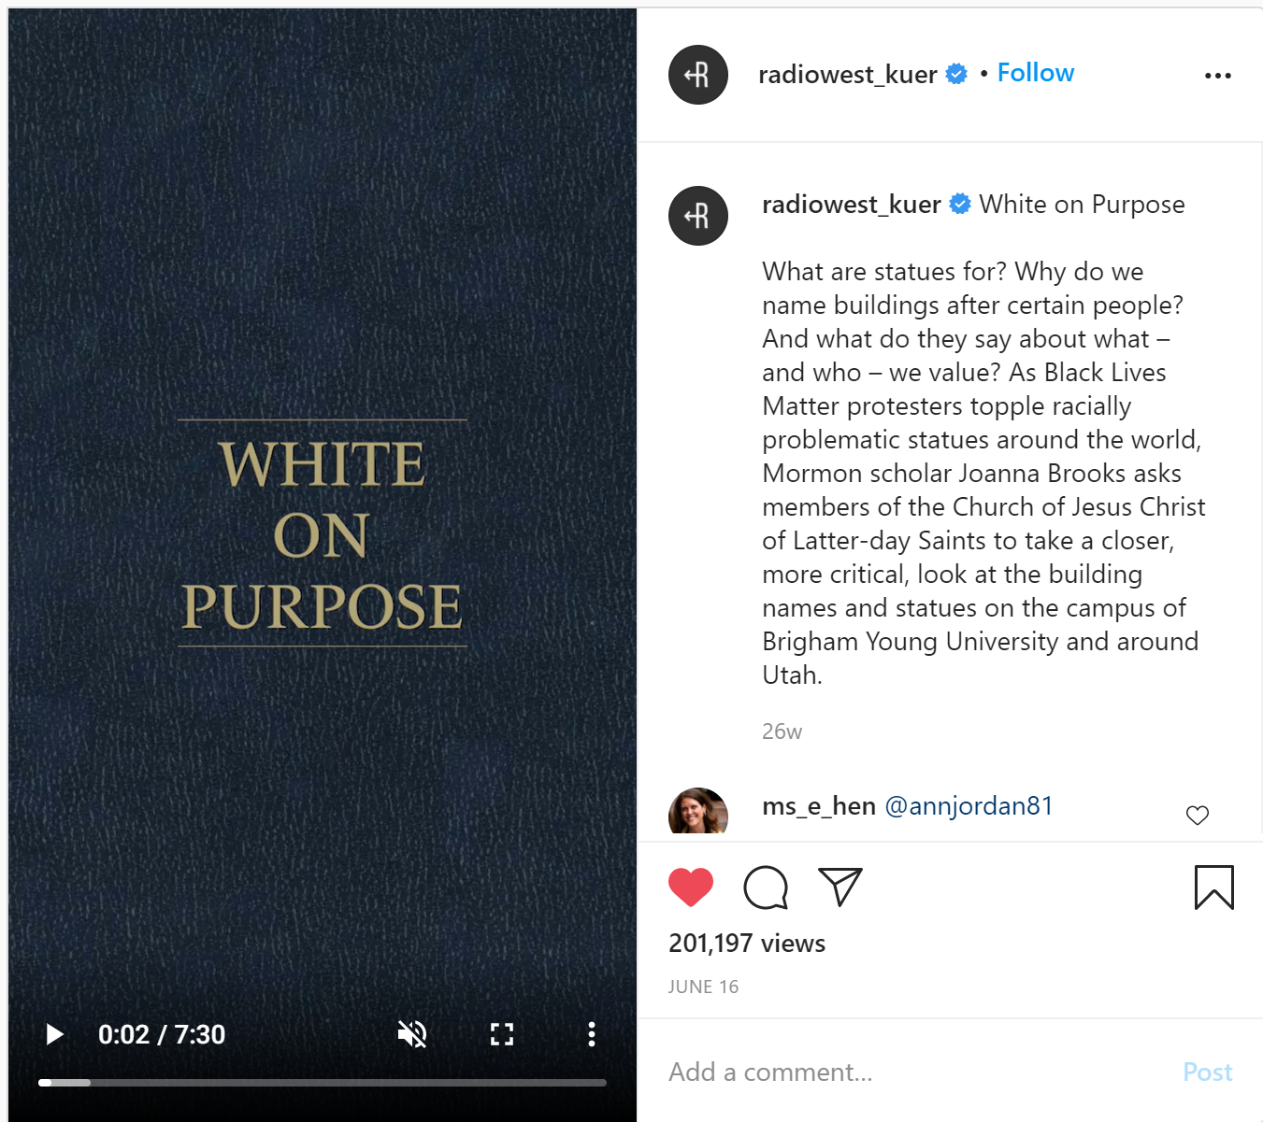

6/16/2020 Instagram post: White on Purpose, 201k views, 1k+ comments (https://www.instagram.com/tv/CBgkE_xhsD1/?utm_source=ig_web_copy_link)

White on Purpose. What are statues for? Why do we name buildings after certain people? And what do they say about what – and who – we value? As Black Lives Matter protesters topple racially problematic statues around the world, Mormon scholar Joanna Brooks asks members of the Church of Jesus Christ of Latter-day Saints to take a closer, more critical, look at the building names and statues on the campus of Brigham Young University and around Utah.

* Reflects intense interest in intersection between white supremacy and the LDS faith and culture

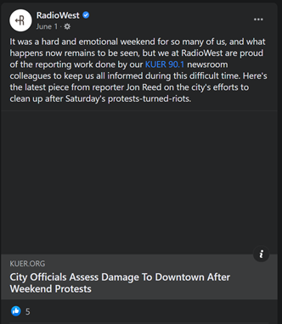

6/1/2020 Facebook post (https://www.facebook.com/RadioWest.KUER/posts/10157770041620141)

“It was a hard and emotional weekend for so many of us, and what happens now remains to be seen, but we at RadioWest are proud of the reporting work done by our KUER 90.1 newsroom colleagues to keep us all informed during this difficult time. Here's the latest piece from reporter Jon Reed on the city's efforts to clean up after Saturday's protests-turned-riots.”

Observations:

* Interesting since seems like it’s trying not to pass judgement on protests until the end, when it does call them riots

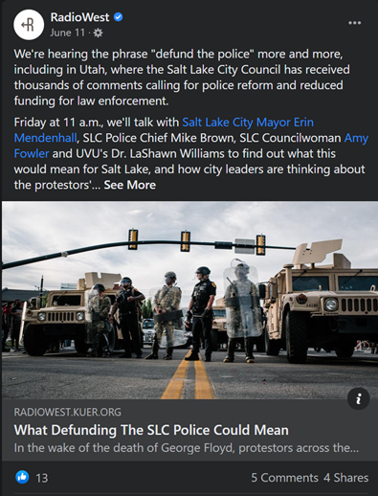

6/11/2020 Facebook post (https://www.facebook.com/RadioWest.KUER/posts/10157801695135141)

“We're hearing the phrase "defund the police" more and more, including in Utah, where the Salt Lake City Council has received thousands of comments calling for police reform and reduced funding for law enforcement. Friday at 11 a.m., we'll talk with Salt Lake City Mayor Erin Mendenhall, SLC Police Chief Mike Brown, SLC Councilwoman Amy Fowler and UVU's Dr. LaShawn Williams to find out what this would mean for Salt Lake, and how city leaders are thinking about the protestors' call for action.”

Sample of Social Media Comments:

* I feel disappointed that not one question was asked of Chief Brown regarding Bernardo Palacios-Carbajal. I'm also disappointed that no one from Black Lives Matter, or from Decarcerate Utah, who were so instrumental in organizing the call for defunding police, were part of the conversation. DU could have probably shed some light on that $30M number.
* Love how the mayor deflected as to demilitarization about how more needs to be spent if we want a police force trained to interact instead of attack. Like maybe you could stop buying assault weapons and assault vehicles, and start spending it on actual training.
* Maybe the public shouldn't own assault weapons and resist arrest. I know I know it's your right to bear arms.
* Maybe people need to be adults and stop destroying others property, stop criminal activity and grow up. Defunding the police is not the answer. If you insist on defunding the police, I can pretty well guarantee violence will escalate

**2. THE JAYMAC SHOW**

RADIO SHOW EPISODE(S)

7/6/2020 Who should apologize, President Trump or Bubba Wallace? (https://open.spotify.com/episode/3cCtsTACQuyYi5tMaukhYw?si=bcF4MKh6SCyJs5ldlvfSJw)

1:45 “And unfortunately, politics have crept their way into our sports because of protest and because the President and others have decided to chime in on what’s happening within specific sports, bringing new attention to these sports, and also bringing, what I consider, new divisions” – Jay McFarland

“…you find moments where the president sough to unite, not to divide. President Lincoln, in his second inaugural address, when the nation was divided in civil war, in his speech, he talked about malice towards none and charity for all. He could’ve used that opportunity to divide and to create hatred. He sought to bring together and to unify. And that’s what should be happening in our trials that we are facing right now. The trials that we are facing over the racial divide. The trials that we’re facing over the pandemic. We should be coming together as a nation. We should be united in a cause that fights freedom and equal and fair treatment for all and that fights for the return of this country to greatness by reopening but doing so in a way that protects everybody and keeps as many people alive as possible.” – Jay McFarland

Observations:

* Surprisingly (to me), Jay does not portray Bubba Wallace negatively and suggests President Trump should’ve handled this conflict better
* He sort of vaguely refers to a bad event that we must unify over, which could be interpreted as the killing of unarmed Black men by police or the noose being left in Bubba Wallace’s locker
* Uses an interview with Senator Lindsay Graham (not conducted by Jay McFarland) to illustrate the point he wants to make that it is a natural reaction for Bubba Wallace to be upset about finding a noose in the locker room and it’s a good business decision for NASCAR and the best decision for the sport of racecar driving to ask fans not to use a symbol of division (interestingly, frames it as an ask from NASCAR, rather than a ban; the symbol in question is the Confederate flag)

Analysis:

* Does not directly address the Black Lives Matter movement but the events of this conflict between Bubba Wallace and President Trump revolved around accusations of racism following the protests over the summer
* Jay seems to have a very specific point he wants to make that President Trump should do be doing more to unify the country and not cause further division
* It seems to me that he is trying very hard to convince his listeners of this, perhaps anticipating that they may not agree with him?

SOCIAL MEDIA ENGAGEMENT

Social Media Accounts:

* Facebook: https://www.facebook.com/JayMac.Mcfarland
* Instagram: https://www.instagram.com/jaymac_for_congress/?hl=en
* Twitter: https://twitter.com/jaymcfarland

Observations:

* Posts on Facebook frequently, often about politics and also about his run for a Congressional seat in the UT District 3 primary election
* Seems to get a lot of public engagement on Facebook, particularly from listeners of his show (at time of analysis, on 11/28/2020)
* Also posts frequently on Twitter, but receives very little engagement there
* Posts on Instagram are almost exclusive to his Congressional campaign and less engagement than Facebook

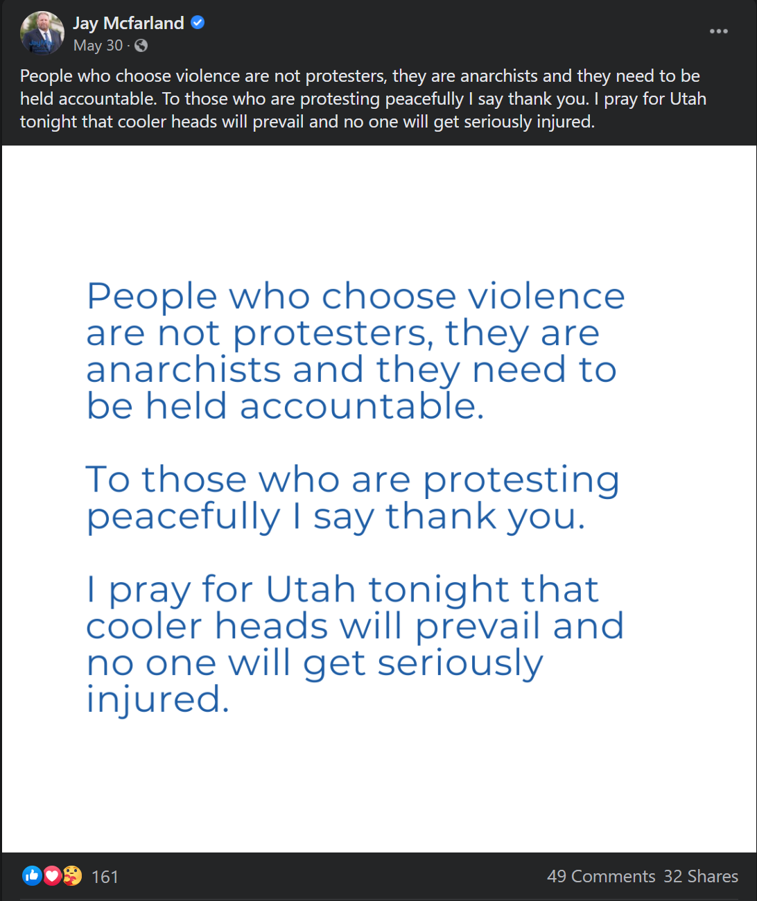

5/30/2020 Facebook Post, 161 reactions, 49 comments, 32 shares (https://www.facebook.com/JayMac.Mcfarland/posts/3141279412680014)

“People who choose violence are not protesters, they are anarchists and they need to be held accountable. To those who are protesting peacefully I say thank you. I pray for Utah tonight that cooler heads will prevail and no one will get seriously injured.”

* Portrays some protestors in negative light, but acknowledges that not all the protestors are violent
* Text repeated in picture format (screenshot below)
* Comments largely in support of his portrayal of these protests, though some express disagreement

Sample of Social Media Comments:

* I understand there's a lot of work that needs to be done to improve the lives of black people. However, seeing people destroy a police car is never the answer. I'm disappointed in my fellow Utahns.
* The arrested protesters should be liable for all damages and lost revenue for all businesses effected.
* There’s a huge difference between protest and riot, one is usually peaceful and one is criminal. If you choose to be criminal then ya get what ya get. Nothing says I love my fellow man like a good looting and a riot. 😐 not to mention your city... 😔
* “Darkness cannot drive out darkness; only light can do that. Hate cannot drive out hate; only love can do that.” I know a lot of people are upset, and rightly so. The officer responsible should be punished. More should be done to eliminate police brutality. I just don’t know how more violence will makes any of this better. Destruction of property and harming other people does not cure racism, it honestly it can perpetuate it. How will those people harmed view the protestors? If their goal is to convince people that racism needs to be addressed in law enforcement they need to change hearts and minds. Attacking only makes people more closed and defensive. We need to be unified in order to combat racism, not more polarized and divided. Look at the great peacemakers, like Dr. King and Gandhi. They recognized that violence only destroys. We need healing, and more compassion.
* Wow, imagine that. A white guy who has never been randomly pulled over and searched by police is complaining about "those rioters." Riots bring change -- just look at the Stonewall riots of 1969. The rule should be if you are white, straight and male you dost not speak.
* Easy to say such things when we are white men. I wonder if we would feel differently watching our people die over and over again?
* They will never get the support they need by using violence. People would have come out in the masses today if they felt they could safely. Cutting off your nose to spite your face leaves you ugly.

6/2/2020 Facebook Post, 75 reactions, 32 comments, 4 shares (https://fb.watch/22VQhk5fWh/)

6/3/2020 Facebook Post, 19 reactions, 39 comments, 5 shares (https://fb.watch/22Wp8hq_p7/)

7/6/2020 Facebook Post, (post of 7/6 podcast), 14 reactions, 75 comments, 0 shares (https://www.facebook.com/JayMac.Mcfarland/posts/3175773012563987)

7/7/2020 Facebook Post, (repost of 7/6 podcast), 5 reactions, 32 comments, 0 shares (https://l.facebook.com/l.php?u=https%3A%2F%2Fwww.podbean.com%2Feau%2Fpb-fsffk-e25185&h=AT2otBKb9EqzpwAYSKKTeIjEuCbKZcue8pQTFTAuUnjABL9Ki9nwmQvRricG59rYT2tOa2uXQ7FExtkvhzCyEjfJUCm_mQosjYCgN3fx60z0jortL2mbOSYTTlpzF4kP4w&s=1)

7/10/2020 Facebook Post, (post of 7/10 podcast), 12 reactions, 8 comments, 0 shares (https://www.facebook.com/JayMac.Mcfarland/posts/3179235372217751)

7/13/2020 Facebook Post, (post of 7/13 podcast), 15 reactions, 26 comments, 1 share (https://www.facebook.com/JayMac.Mcfarland/posts/3181923738615581)

**3. THE LISA SHOW**

RADIO SHOW EPISODE(S)

(6/5/2020) Uncertainty, True Crime, Murals and COVID-19, Sleep Schedules, Summer Eating, Eating Takeout, Weekend Review (https://www.byuradio.org/episode/d404a781-1111-4c65-aebb-4d4d818b2db6/the-lisa-show-uncertainty-true-crime-murals-and-covid-19-sleep-schedules-summer-eating-eating-takeout-weekend-review)

1:02 “First the pandemic and now riots across the country… I feel like I can’t ever leave my house! A lot of people feel like they shouldn’t.” – Lisa Clark

1:19 “Murder hornets, uh, riots, pandemic – what else are we doing?” – Richie T. Steadman

5:31 “I’m willing to allow this uncertainty. I’m going to let go of trying to struggle with it. I’m going to let go of trying to confirm what’s going to happen and maybe that means not watching so much news, not, you know, obsessively scrolling your feed to see how many people died today, where were the riots. So really coming back to the present moment and accepting that you are sitting in the not knowing.” – Dr. Lara Fielding

19:12 “I got your morning buzz. It’s three stories that are trending online right now. I have them for you. Allow me, if you will, to present them to you. Uh, this first one, it’s the first of three memorials for George Floyd, the man who was murdered in Minneapolis. It took place yesterday. The Reverend Jesse Jackson was on hand, as well as, um, Senator Amy Klobuchar, both in attendance, as well as Ilhan Ohmar, Sheila Jackson Lee, Ayanna Presley, and Joyce Beatty. Rappers TI along with his wife, Tiny, Ludacris, Tyrees Gibson, comedians Kevin Hart and Tiffany Haddish, as well as Marcei Martin, all in attendance. Uh, that was the memorial that took place in Minneapolis. The - he will be laid to rest, I believe, in Houston later this week. Uh, also if you remember the ‘ain’t nobody got time for that’ or ‘hide yo kids, hide yo wife’ – those songs that were created out of news pieces in the past….” - Richie T. Steadman

Observations:

* Only mentions a small reference to what’s going on in the world (wrt BLM movement) as premise for discussion with a clinical psychologist on mindful practices to handle uncertainty
  + Then later directly states information about George Floyd’s murder and his memorial but only as a news announcement and not part of a discussion on the topic – the co-host quickly moves on to announce other headlines of the day
* Frames it as riot every time it is mentioned – by the host, co-host, and interviewee (clinical psychologist) – the co-host and interviewee take the host’s portrayal at its face and run with it

Analysis:

* Does not address my RQ: they don’t refer to any BLM-related organization because they only mention it in passing/as context for the programmed discussion
* In general, reflects my understanding of the movement in Provo – controversial subject to be avoided, especially by women
  + Supported by lack of controversial topics on their social media pages

SOCIAL MEDIA ENGAGEMENT

Social Media Accounts:

* Facebook: https://www.facebook.com/lisavclarkshow
* Instagram: https://www.instagram.com/lisavalentineclarkshow
* Twitter: https://twitter.com/lisavclarkshow

Observations:

* No related posts on Facebook, Instagram, or Twitter
* Also seems the show avoids controversial topics and language, both on the show and in social media posts
* Not many comments from members of the public on any of these platforms in general
* Suggests audience is older and/or not as closely engaged on social media, or possibly not a very close community of listeners on this show

**4. TOP OF MIND WITH JULIE ROSE**

RADIO SHOW EPISODE(S)

5/28/2020 Hong Kong, Jon the Robot, Race and Film (https://www.byuradio.org/episode/71e0c8d3-33d6-4763-af32-b9cf0df436ee/top-of-mind-with-julie-rose-hong-kong-jon-the-robot-race-and-film)

50:19 “We’ll consider how Hollywood films have shaped America’s views on race and can be a tool for starting the conversations we need to have and we need to keep having” – Julie Rose

50:40 “Ahmaud Arbery and George Floyd. Both unarmed black men killed by white men. Both incidents came under scrutiny only after cellphone video was made public. Ahmaud Arbery was jogging in a Georgia neighborhood when he was shot dead by a retired law enforcement officer and his son, who have now been charged with murder. George Floyd died in Minneapolis police custody this week. Bystander video of the arrest shows Floyd on the ground, struggling to breathe as a white police officer kneels on Floyd’s neck for several minutes. The officers involved in that incident have been fired and the FBI is investigating. Video is a powerful tool to prompt scrutiny, spark outrage and, hopefully, bring change. Baylor University theologian and film scholar Greg Garrett has spent the last several years using film of a different sort to prompt scrutiny, outrage and, hopefully – change – in the way white Americans think about race.”

Observations:

* Guest Greg Garett discusses how it can be hard to talk about race and racism without feeling emotional and tripping up over your own feelings, but stories told through film allow us to think about these issues and talk about them without necessarily positioning ourselves in the narrative
* Film allows white people to experience some of what Black people experience

Analysis:

* Overall, the show host openly acknowledges and portrays George Floyd’s death as an unjust killing, the guest seems to agree and argues for the role of video and film to combat racism in America
* Although they do not directly address the Black Lives Matter movement, they appear to be in support of it and suggest ways to further interrogate racism and other racial injustice in the U.S.
* No mention of any Black Lives Matter-related organizations

6/3/2020 Police Force, Antarctica Forest, Impostures (https://www.byuradio.org/episode/509024fa-dcc5-4c69-a3b7-f19c8b251eed/top-of-mind-with-julie-rose-police-force-antarctica-forest-impostures)

0:30 “Curfews are in effect in cities across the country, hoping to quell the violence that has accompanied protests. People are in the streets demanding reform to how police use force and how they are held accountable when they kill unarmed Black people. President Trump says governors and law enforcement need to ‘dominate’ the protestors. Videos of police officers using tear gas, rubber bullets, and batons on peaceful protestors have only inflamed tension.” – Julie Rose

1:18 “So as I mentioned, President Trump argues the reason protests seem to have spiraled out of control is because cities and states aren’t being tough enough, but I wonder if cracking down harder would only bring more people to the streets, or make them behave more badly – what’s the tension there?” – Julie Rose

Observations:

* Guest Michael Sierra-Arévalo discusses research on protests and how police violence in response to unrest escalates or exacerbates protest violence

Analysis:

* Host’s framing of the protests was careful not to describe the violence as inherent to the protest: “violence that has accompanied protests” does not assign blame or responsibility for the violence to protestors or even as a result of the protests themselves
* Host and guest both acknowledge racism and racial injustice and suggest support for the goals of equality in the Black Lives Matter movement
* Does not address organization wrt Black Lives Matter movement but guest does talk about the goals of the abolitionist movement within broader movement as being to rethink the use of police and police force in American society

6/4/2020 What Whites Need To Know, Missing Strangers, Musical Theatre (https://www.byuradio.org/episode/4207318d-d115-4119-9ae8-0c0649c5bc89/top-of-mind-with-julie-rose-what-whites-need-to-know-missing-strangers-musical-theatre)

0:30 “All four Minneapolis police officers who were on the scene when George Floyd was suffocated have now been arrested and charged with murder or aiding in the murder. Protests against racial inequality and police violence continue to fill streets across the country, with no sign of ending. We are going to spend the next few minutes talking exploring how the color of your skin may be affecting your view on the protests.” – Julie Rose

1:45 “So I know there are all kinds of new white people being suddenly, newly awakened. And um it’s a hard place to be. It’s – I was there 12 years ago. I remember when I started to understand that the country that I was taught that I lived in is not the country that I live in. And it’s uh, that creates a lot of dissonance. It’s a lot easier to confirm an old belief than to challenge a belief that we have and let a new one in and I think that’s a state that a lot of people are in right now. How could this be? How in 2020, could this be?” – Debby Irving

2:24 “Although we’ve certainly seen videos, um and we’ve actually, you know, seen protests against the killing of unarmed Black men by white officers, do you think there’s something different about this because of that video, because of being able to see George Floyd on the ground with an officer kneeling on his neck for 8 minutes while other officers stood by and did nothing? Do you think that, do you think that unambiguous nature of that, that it is, I would argue, impossible to watch that video and not say, that is wrong, why is that happening in America? Is that part of what’s different here, do you think?” – Julie Rose

Observations:

* Host frames topic at the start as consequences of police actions
* Host describes protests with neutral or positive tone, attributes violence to police
* Guest Debby Irving describes how George Floyd’s murder sparked public outcry in a much different way than condemnation for racial injustice has taken place in the past
  + As result of many factors: many people at home because of the pandemic are already in a state of dissonance and multiple highly publicized killings of Black people within a short time period
  + Consequence is a palpably different experience of understanding racial injustice for white people

Analysis:

* Host and guest discuss the experience of awakening to realities of racial injustice in our country (specific to the perspective of white people, for the most part), so this discussion appears targeted at white audiences
* Host and guest both acknowledge racism and racial injustice and suggest support for the goals of equality in the Black Lives Matter movement
* Does not address organizational aspect of the movement

SOCIAL MEDIA ENGAGEMENT

Social Media Accounts:

* Facebook: https://www.facebook.com/byutopofmind/
* Instagram: https://www.instagram.com/byutopofmind/
* Twitter: https://twitter.com/BYUTopofMind

Observations:

* Only 1 related post on Facebook, Instagram, or Twitter
* Very limited engagement from members of the public overall
* One interesting difference is their Twitter account has substantially more posts than Facebook or Instagram, despite pretty consistent engagement across platforms
* Signals radio show leadership believes their target audience is more on Twitter, may see the Academic Twittersphere as their target audience?

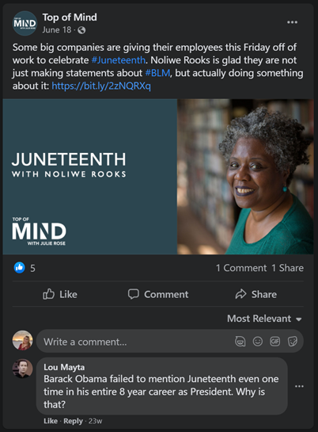

6/18/2020 Facebook post discusses Juneteenth, has 1 negative comment but no further engagement (https://www.facebook.com/byutopofmind/photos/a.1234222186624706/3138275552886017/)

* Sole comment: Barack Obama failed to mention Juneteenth even one time in his entire 8 year career as President. Why is that?
  + Comment is ambiguous and could be interpreted as positive or negative (the first: implying our former president should’ve talked about this important occasion and historical event; the second: implying Juneteenth is not an important and historic holiday that ought to be celebrated)
  + Based on this Facebook user’s public content feed, I think it’s safe to assume he meant the second – his feed is very alt-Right, full of Fox News shares, pro-Trump memes, anti-Trump conspiracies, and hysteric language = interpreting this comment as negative

QUALITATIVE ANALYSIS: NEWS REPORTING

**1. KUER**

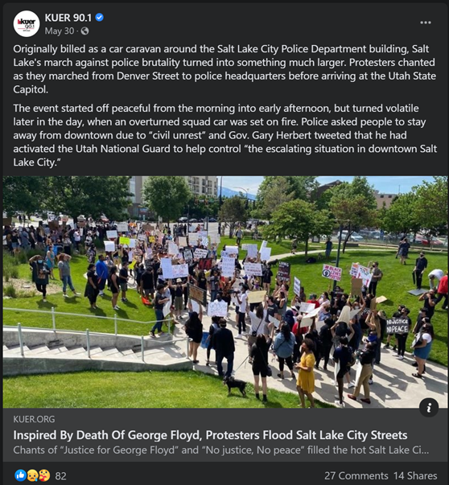

5/30/2020 Article: Inspired By Death of George Floyd, Protestors Flood Salt Lake City Streets (https://www.kuer.org/justice/2020-05-30/inspired-by-death-of-george-floyd-protesters-flood-salt-lake-city-streets#stream/0)

FACEBOOK POST

* Originally billed as a car caravan around the Salt Lake City Police Department building, Salt Lake's march against police brutality turned into something much larger. Protesters chanted as they marched from Denver Street to police headquarters before arriving at the Utah State Capitol. The event started off peaceful from the morning into early afternoon, but turned volatile later in the day, when an overturned squad car was set on fire. Police asked people to stay away from downtown due to “civil unrest” and Gov. Gary Herbert tweeted that he had activated the Utah National Guard to help control “the escalating situation in downtown Salt Lake City.”

SOCIAL MEDIA ENGAGEMENT

* 82 reactions, 27 comments, 14 shares

Sample of Social Media Comments:

* Old enough to remember, that often during the Civil Rights Era, many peaceful protests turned into riots because , as was later found out paid disrupters would show up and a peaceful protest would turn ugly. We've got to be careful not to be quick to judge, because there are powerful people who would like to keep our country divided, and for the White community to not have sympathy for the marginalized and oppressed people. #BlackLivesMatter
* I do not support the violence and destruction but I understand the frustration and rage that leads to it.
* Trash
* Except it wasn't "billed" as a car caravan - it was organized as such. Please don't make it look like a bait-and-switch.

Observations:

* Article portrays protest fairly positively, though the “originally billed” language does paint it as an event that deceived the public on how it was planned
* Not much social media engagement in comparison to SL Tribune

**2. THE SALT LAKE TRIBUNE**

5/30/2020 Article: Salt Lake City is under curfew as a rally to protest death of George Floyd turns violent. Gov. Herbert activates National Guard. (https://www.sltrib.com/news/2020/05/30/rally-protests-death/)

FACEBOOK POST

* Governor Gary Herbert said he activated the National Guard to "help control the escalating situation in downtown Salt Lake City." (https://www.facebook.com/saltlaketribune/posts/10158305416274399)

SOCIAL MEDIA ENGAGEMENT

* 833 reactions, 576 comments, 551 shares

Sample of Social Media Comments:

* They need to get those people that were arrested go clean up all the mess. Maybe they will think twice next time to not throw trash on the ground because some one has to clean it up, and it may be them. Only fitting.
* This veteran salutes every one of you who knowingly risk yourselves to exposure to the pandemic to stand for justice. That's the America I served to defend and preserve. 🙌 respect. Please isolate yourselves responsibly when you're finished.
* I just passed by the demonstration. Only 2 lanes were used. They were not jamming anything! It was respectful, very beautiful. I was crying passing them from the free lanes and thanking them for what they were doing!
* That's right, burn my tax money. I cannot support this.
* So sick of pandering reporters interviewing rioters and...trying to "understand" and support them. Awhhhhhhh.. Protest is not violence!!

Observations:

* Headline and article portrays protest in more negative light than later coverage – “protest turns violent” assigns responsibility of violence on those participating in protest
* Article seems unsure of who to blame for violence; also conflates violence and property damage
* Comments in support of protest got the most likes, likely reflecting liberal-leaning audience
* Facebook algorithm interestingly showed comments in surprising order – not by most likes. Possibly chronologically? But hard to tell at this point because time posted is not displayed in enough detail.

**3. KSL NEWS**

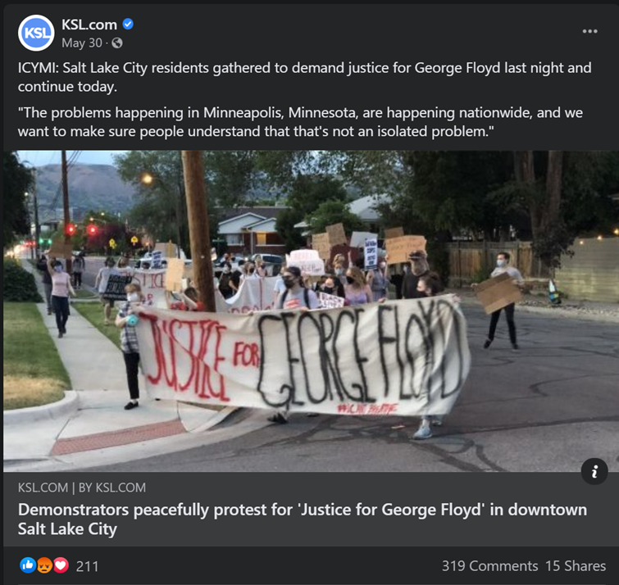

5/29/2020 Article: Demonstrators peacefully protest for 'Justice for George Floyd' in downtown Salt Lake City (https://www.ksl.com/article/46758807)

FACEBOOK POST (posted 5/30/2020)

* “ICYMI: Salt Lake City residents gathered to demand justice for George Floyd last night and continue today. "The problems happening in Minneapolis, Minnesota, are happening nationwide, and we want to make sure people understand that that's not an isolated problem." (https://www.facebook.com/kslcom/posts/10158843085879172)

SOCIAL MEDIA ENGAGEMENT

* 211 reactions, 319 comments, 15 shares

Sample of Social Media Comments:

* What about “justice” for the young police officer in Ogden who gave his life while responding to a call for help? What about showing some gratitude for his selfless act and some sympathy and support for his family? That’s closer to home and to a real life circumstance here in Utah.
* justice for him or them? He wouldn't want this. years from now, people will remember only that crimes were committed in his name and the family won't be able to heal because of it
* Your protest made no sense, and it's completely irrelevant to the area. Not only is justice already being served to the officers actually involved, but SLC PD already proved they won't tolerate an officer abusing his power when they fired Payne. There was no (logical) reason to "protest"; stand in unity, yes, of course. But regardless, at least props to those who didn't start acting like tantrum-throwing babies and stayed peaceful.
* SLC cannot give Floyd justice. I want justice for the riots in SLC. Justice for the damage caused by these riots. Justice for SLC!!!

Observations:

* Headline and article are largely positive toward protests (not the case after latter half of May 30 protest – KSL coverage was very negative after that)
* Despite that, comments are largely negative and condemn the protests
* It also seems that a lot of commenters didn’t see this article until after the May 30 protest continued (which had “violence” = property damage) and were upset about the coverage that it was “peaceful”

**4. DESERET NEWS**

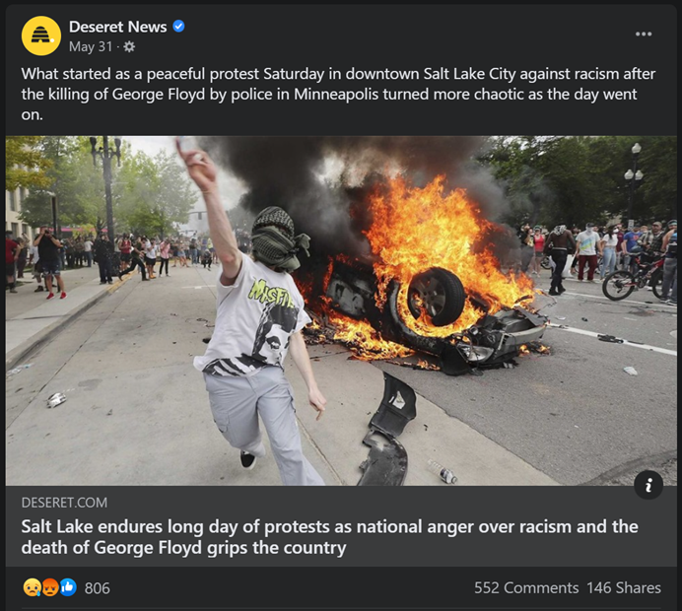

5/30/2020 Article: Salt Lake endures long day of protests as national anger over racism and the death of George Floyd grips the country (https://www.deseret.com/utah/2020/5/30/21275674/salt-lake-city-curfew-protest-library-square-george-floyd-killing-police-car-herbert-national-guard?utm_source=facebook&utm_medium=deseretnews&utm_campaign=facebookpage)

FACEBOOK POST

* “What started as a peaceful protest Saturday in downtown Salt Lake City against racism after the killing of George Floyd by police in Minneapolis turned more chaotic as the day went on.” (https://www.facebook.com/deseretnews/posts/10158409352234655)

SOCIAL MEDIA ENGAGEMENT

* 806 reactions, 552 comments, 146 shares

Sample of Social Media Comments:

* Peaceful? I'm so put off by this, the news,the people, it makes me ashamed of our state. I'm sure these are not the peace loving people that believe in love one another. The problem they were using didn't happen here. It happened in another state and had been adressed by the athorites. It was am excuse. Most of these people were not from here.
* These people are out here burning up cars and burning down businesses are all funded by George Soros Hillary Clinton Barack Obama oh, the liberal Democratic Party and the Socialist. They were all expecting to have a wide support from the African American Community as well as other other ethnic groups and they're finding out they're not getting it it's turned on them and it will turn on the people that are funding this as well. These people that are out there doing this damage they think they are starting a new Revolution, in fact they don't have the brains enough to start a lawn mower. These people that are burning these cars and the tag of the police, would fall into a good category being Prime candidates of abortion at Birth. They serve no God accept Satan and we know who serve Satan and that's the liberal party. All I can say is God Bless America
* Good. Let's keep it up!
* Same old story through out history. Terrorist love Terror! They cloak it with a cause so they can carry out their terror. Rioters and looters love rioting and looting. And if they can attach a cause to it? Then they feel justified in their rioting and looting. Which is what they wanted to do the whole time. True Joy and Peace only comes from following and serving the Savior Jesus Christ! Help the poor and needy. Feed and cloth the hungry. As you serve and help others. True change happens to us all. Jesus Christ is the answer!

Observations:

* Headline and post actually seem more neutral and positive towards the protest than other news coverage, but news article itself portrays the protest more negatively
* Article seemed a lot more sympathetic to police officers – more attention on their efforts to stem the “violence”, interviews and quotes, etc.
* Comments are very negative, but also extremely partisan and reference other partisan fights (George Soros, Hillary Clinton, etc.) in comparison to comments on KSL article
* Interesting that the more neutral headline seems to have triggered more impassioned responses from the public than other news article posts on Facebook

**5. DAILY HERALD**

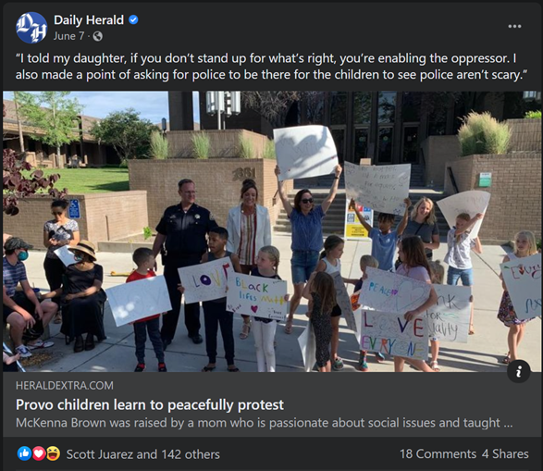

6/6/2020 Article: Provo children learn to peacefully protest (https://www.heraldextra.com/news/local/central/provo/provo-children-learn-to-peacefully-protest/article_4b4b2146-4c61-55d4-97ee-bd44f24ba7c8.html)

FACEBOOK POST

* “I told my daughter, if you don’t stand up for what’s right, you’re enabling the oppressor. I also made a point of asking for police to be there for the children to see police aren’t scary.” (https://www.facebook.com/UtahValleyDailyHerald/posts/10157600944659366)

SOCIAL MEDIA ENGAGEMENT

* 143 reactions, 18 comments, 4 shares

Sample of Social Media Comments:

* The road to Hell is paved with good intentions...
* Children have no place at a protest. Even a pretend one like this. They do not understand what is written on their signs. Let them be kids.
* I would rather they read Common Sense, than be force-fed this...
* Lots of meme and gif comments:

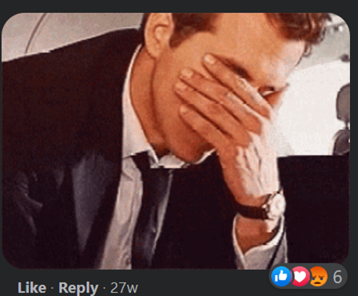

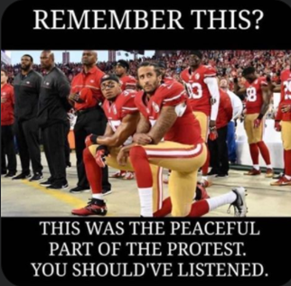

Observations:

* Headline, post, and article are largely positive of the Black Lives Matter movement and protests
* Comments are extremely negative, though less engagement than other news outlets
* Meme and gif responses in the comments (in comparison to almost none in other news article posts on Facebook) suggest this outlet’s audience skews younger

1. Two prominent examples of this type of listener engagement are NPR’s radio show/podcast “It’s Been a Minute with Sam Sanders” and WBEZ Chicago’s radio show/podcast “Nerdette”.
2. One way this has been described is “being extremely online”.
3. LDS is short for the Church of Jesus Christ of Latter-Day Saints, which is based in Salt Lake City, UT and is the predominant religion in the state.